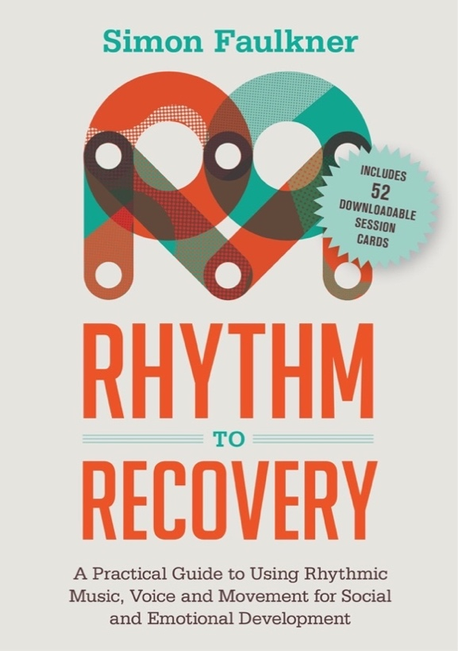
Workshop topics include rhythm exercises for:

- Developing trust
- Communication
- Emotional regulation
- Motor coordination
- Managing Change
- Managing Adversity
- Grief & Loss
- Mindfulness
- Exploring Relationships
Incorporating
Positive Psychology
& Mindfulness

This training, from the author of the multi-award-winning DRUMBEAT program, is a new flexible approach, designed for professionals in the health and education sectors wishing to utilise rhythm based exercises into their practice.
Based on the latest evidence, and research into the way rhythm impacts the brain, this work is full of fun and practical exercises to engage people of all ages and backgrounds in social and emotional learning.
We Are Seeking Expressions of Interest in bringing
The Rhythm2Recovery Training
(Music as a tool for Social & Emotional Development)
to
Fill in Name of Location Here

Simon Faulkner gets to the soul of rhythm and its potent use when working with individuals, families, and groups of all ages. This training is a treasure. It’s a must-do for anyone working in a therapeutic or educational context. When words get in the way, tune in to the principles that Rhythm2Recovery offers in this packed filled workshop.

Dr. Daryl Chow, MA, Ph.D. (Psych ) Counselling Psychologist, Senior Associate & Trainer, International Centre for Clinical Excellence (ICCE).

NO MUSICAL EXPERIENCE NECESSARY
Watch a video on the R2R model here http://www.rhythm2recovery.com/watch-video/
For detailed information on training content visit www.rhythm2recovery.com

To register your interest in attending this training contact: Add contact name & email address here

